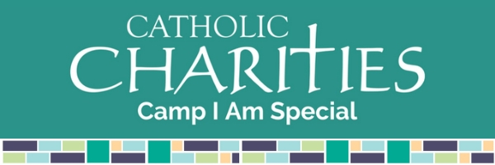

2023 BEHAVIORAL PLAN
This page is meant as a place holder, this is where you will upload your childs Behavioral plan (any documentation can help us meet their needs best!)

